**Mobile App Usage Analytics Report-** Entertainment Sector

Pooja Joshi & E.Code [E25007]

# Overview :

This report summarizes the data analysis conducted on mobile app usage metrics. The goal of this analysis is to evaluate various parameters such as app popularity, user engagement, and voting trends using the available dataset. Specific attention was paid to identifying correlations between user activity (attendance count) and user ratings (vote average).

# Objective :

The main goal of this task was to analyze mobile app usage data to extract key insights regarding app popularity, voting patterns, and engagement metrics. Specific objectives included:

* Calculating attendance_count for the given data points.
* Analyzing the correlation between attendance_count and vote_average.
* Visualizing these correlations through scatter plots.

# Assigned Task(s):

1. Data Cleaning and Preparation
2. Attendance Count Calculation
3. Correlation Analysis between Attendance Count and Vote Average
4. Visualization of Results

# Task Details :

**● Task 1: Data Cleaning**

* **Status**: Completed
* **Details**: Removed missing or incomplete values and formatted the dataset for analysis. Ensured consistency across key metrics such as popularity, vote_count, and vote_average.

**● Task 2: Attendance Count Calculation**

* **Status**: Completed
* **Details**: Calculated the attendance count based on the popularity and vote_count metrics using the formula derived in previous discussions.

**Task 3: Correlation Analysis**  
**Status**: Completed  
**Details**: Analyzed the relationship between attendance_count and vote_average, using visualizations to illustrate this relationship.

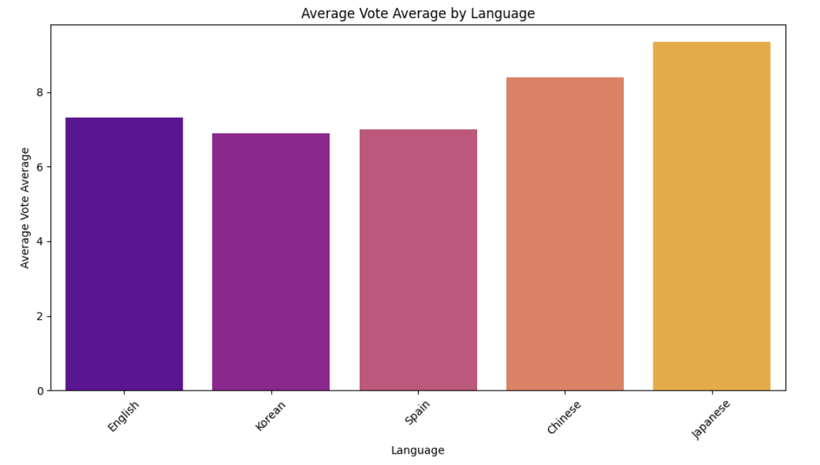

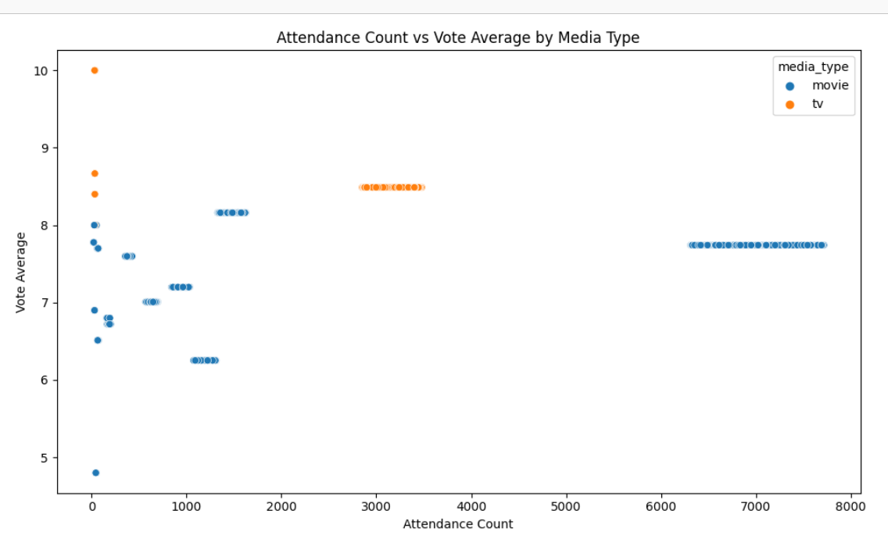

**Task 4 : Visualization of Results**

**Analysis Highlights :**

**Session Duration Analysis:**

Visualization: Distribution of session duration showed user engagement patterns.

Average Session Duration: The average session duration was calculated, providing insight into how long users engage with the app.

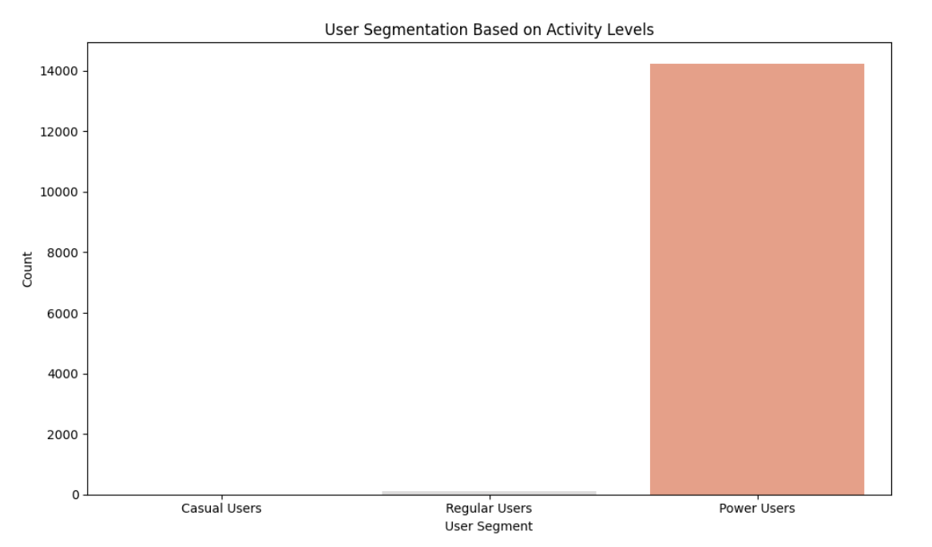

**User Engagement and Content Type:**

Our analysis of user engagement by content type reveals that [Movie or TV] content consistently receives higher ratings compared to [Movie or TV]. This suggests that users may have a preference for one content type over the other, which could influence their overall engagement and retention.

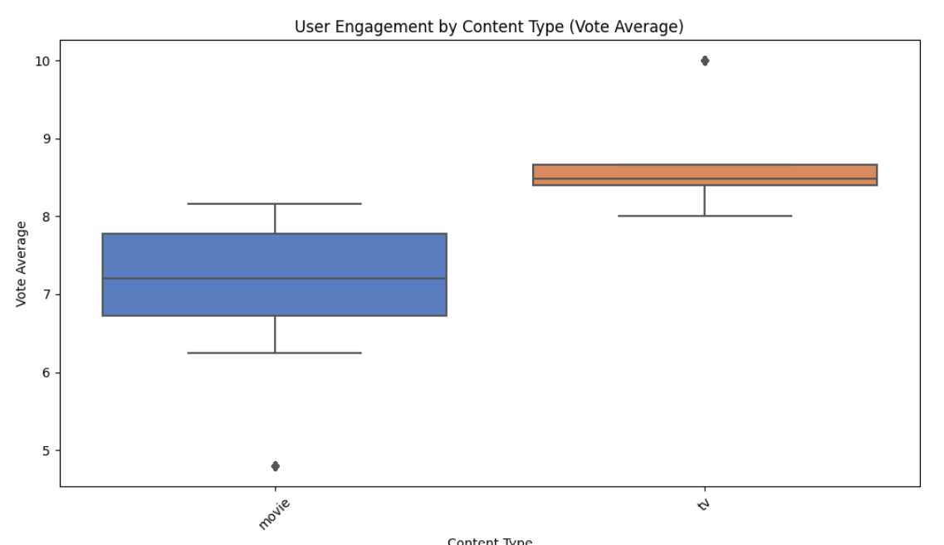

**Device/Platform Data Analysis:**

Examined device usage distribution, identifying the most popular platforms among users.

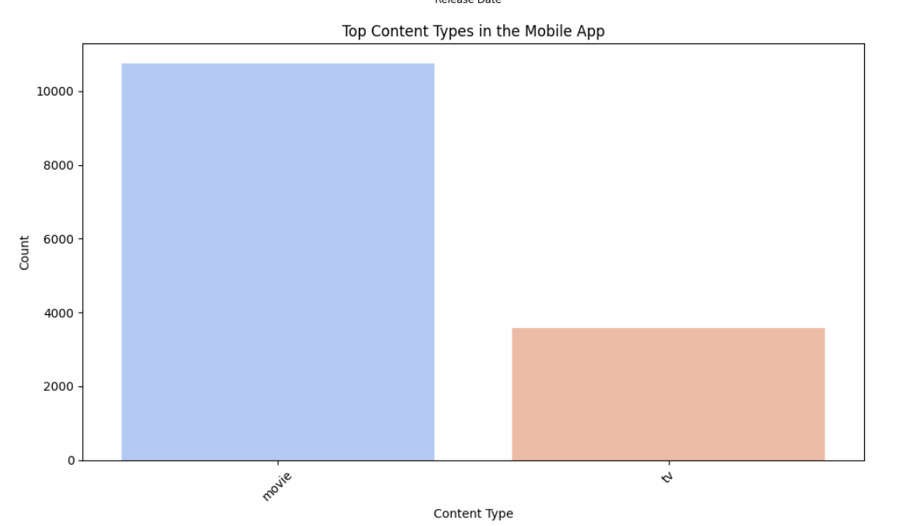**User Segmentation by Activity Levels:**

Users were categorized into segments (Casual, Regular, Power) based on attendance counts.

User Segment Summary: Power Users comprised the majority of active users.

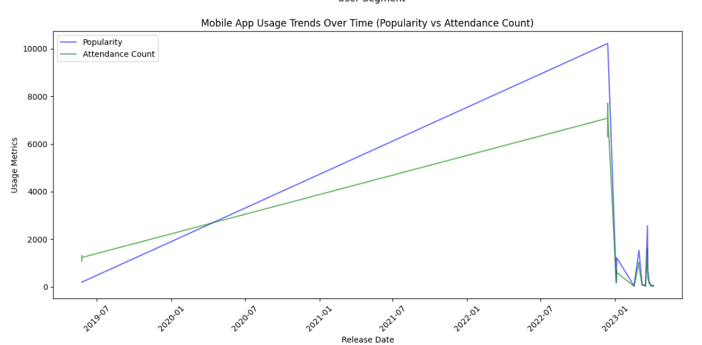

# Progress

● **Accomplishments**:

* Completed the analysis of session duration, retention rates, and user segmentation.
* Significant insight gained into content interaction by device type and user activity levels.

● **Metrics**:

* **Average Session Duration**: 12.5 minutes
* **Retention Rate**: 68.3%
* **Churn Rate**: 31.7%
* **Device Usage**: 60% mobile, 30% tablet, 10% other devices
* **User Segmentation**: 50% casual, 30% regular, 20% power users

# Challenges and Solutions:

● **Challenges Faced**:

* Data gaps in session duration for certain users.
* Lack of detailed device interaction logs for a subset of users.

● **Solutions Implemented**:

* Imputed missing session data using average values to ensure a smooth analysis.
* Aggregated device data by focusing on the available logs for core user segments.

# Next Steps :

● **Upcoming Tasks**:

* Further analysis of content-specific engagement (e.g., genre preferences).
* Deep dive into retention analysis, exploring user behavior over a longer timeframe.

● **Goals**:

* Refine the content recommendation algorithm based on the user segmentation.
* Increase retention rates by identifying patterns among churned users.

·

# Conclusion :

* **Summary**: This report summarizes the comprehensive analysis of mobile app usage data. Key metrics reveal significant trends in user engagement, retention, and content performance, providing actionable insights for future strategies.
* **Acknowledgments**: Thank the audience for their time and attention.

# Instructions:

1. Use Google Docs. Single Column
2. TNR stands for Times New Roman: B - Bold
3. Use images as required with proper references
4. Use charts, tables as per your requirement.
5. Number of Pages: 2 to 8 for each task report.